JAVA SWING BASED – PERSONAL COUNSELLING MANAGEMENT SYSTEM-SQL CONNECTIVITY USING JDBC
A
Report
Submitted in partial fulfilment of the Requirements for the award of the Degree of
BACHELOR OF TECHNOLOGY
IN

INFORMATION TECHNOLOGY

By

DEVARAKONDA SREE SURYA
<1602-20-737-043>

Under the Guidance of

B. Leelavathy


Department of Information Technology Vasavi College of Engineering (Autonomous) (Affiliated to Osmania University) Ibrahimbagh, Hyderabad-31

2021-2022

BONAFIDE CERTIFICATE
This to Certify that the project report titled

“PESONAL COUNSELLING MANAGEMENT SYSTEM” project work of Mr.D.SREE SURYA bearing Roll.no:1602-20-737-043 who carried out this project under my supervision in the IV semester for the academic year 2021-2022.

Signature Signature
external examiner internal examiner

ABSTRACT:
Personal Counselling Management System aims to simplify the interaction between students and counsellors. It is like Mentor – Mentee interaction. The present system is manual and maintains a written record of the issues and interactions with the students which is tedious. This system provides a convenient way to track and tackle student issues. Students can post any issues regarding academics or personal, which will be notified to the counsellor/mentor, and it will be addressed.

INTRODUCTION:

Requirement Analysis

List of tables:
1)Student Login
2)Mentor Login
3)Student
4)Mentor
5)Issues
6)Solution

List of attributes with domain types:

1)Student Login:
USERNAME: VARCHAR2(18)
PASSWORD: VARCHAR2(10)

2)Mentor Login:
USERNAME: VARCHAR2(18)
PASSWORD: VARCHAR2(10)

3)Student:
STUDENT_ID: VARCHAR2(18)
STUDENT_NAME: VARCHAR2(30)
STUDENT_PHONE: NUMBER(10)
STUDENT_EMAIL: VARCHAR2(30)
ISSUES_SUBMITTED: NUMBER
COUNSELLOR_ID: VARCHAR2(10)

4)Counsellor:
COUNSELLOR_ID VARCHAR2(10)
COUNSELLOR_NAME VARCHAR2(20)
COUNSELLOR_PHONE NUMBER(10)
ISSUES_ADDRESSED NUMBER

5)Issues:
ISSUE_ID VARCHAR2(12)
STUDENT_ID VARCHAR2(18)
COUNSELLOR_ID VARCHAR2(10)
TITLE VARCHAR2(15)
DESCRIPTION VARCHAR2(200)
STATUS VARCHAR2(10)
SUBMISSION_TIME DATE

6)Solution:
ISSUE_ID VARCHAR2(12)
STUDENT_ID VARCHAR2(18)
COUNSELLOR_ID VARCHAR2(10)
RESPONSE VARCHAR2(200)
ARCHITECTURE AND TECHNOLOGY USED:

SOFTWARE USED:
Java Eclipse, Oracle 11g Database, Java SE version 8, SQL Plus.

Java SWING:
Swing is a GUI widget toolkit for Java. It is part of Oracle's Java Foundation Classes (JFC) – an API for providing a graphical user interface (GUI) for Java programs.
Swing was developed to provide a more sophisticated set of GUI components than the
earlier AWT. Swing provides a look and feel that emulates the look and feel of several platforms, and also supports a pluggable look and feel that allows applications to have a look and feel unrelated to the underlying platform. It has more powerful and flexible components than AWT. In addition to familiar components such as buttons, check boxes and labels, Swing provides several advanced components such as tabbed panel, scroll panes, trees, tables, and lists.

SQL:
Structure Query Language (SQL) is a database query language used for storing and managing data in Relational DBMS. SQL was the first commercial language introduced for E.F Codd's Relational model of database. Today almost all RDBMS (MySql, Oracle, Infomix, Sybase, MS Access) use SQL as the standard database query language. SQL is used to perform all types of data operations in RDBMS.

Java-SQL Connectivity using JDBC:
Java Database Connectivity (JDBC) is an application programming
interface (API) for the programming language Java, which defines how a client may access a database. It is a Java-based data access technology used for Java database connectivity. It is part of the Java Standard Edition platform,
from Oracle Corporation. It provides methods to query and update data in a database and is oriented towards relational databases.
The connection to the database can be performed using Java programming (JDBC API) as:

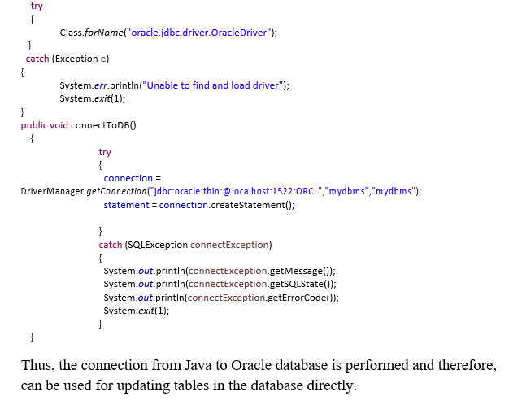

Table Created in SQL for above mentioned purpose is as:

SQL> create table studentlogin(username VARCHAR2(18),PASSWORD VARCHAR2(10));

Table created.

SQL> create table mentorlogin(USERNAME VARCHAR2(18),PASSWORD VARCHAR2(10));

Table created.

SQL> create table student(STUDENT_ID VARCHAR2(18),STUDENT_PHONE NUMBER(10),STUDENT_EMAIL VARCHAR2(30),ISSUES_SUBMITTED NUMBER,COUNSELLOR_ID VARCHAR2(10));

Table created.

SQL> create table counsellor(COUNSELLOR_ID VARCHAR2(10), COUNSELLOR_NAME VARCHAR2(20),COUNSELLOR_PHONE NUMBER(10),ISSUES_ADDRESSED NUMBER);

Table created.

SQL> create table issues(ISSUE_ID VARCHAR2(12),STUDENT_ID VARCHAR2(18),COUNSELLOR_ID VARCHAR2(10),TITLE VARCHAR2(15),DESCRIPTION VARCHAR2(200),STATUS VARCHAR2(10),SUBMISSION_TIME DATE);

Table created.

SQL> create table solution(ISSUE_ID VARCHAR2(12), STUDENT_ID VARCHAR2(18),COUNSELLOR_ID VARCHAR2(10),RESPONSE VARCHAR2(200));

Table created.

DESIGN:

ER Diagram

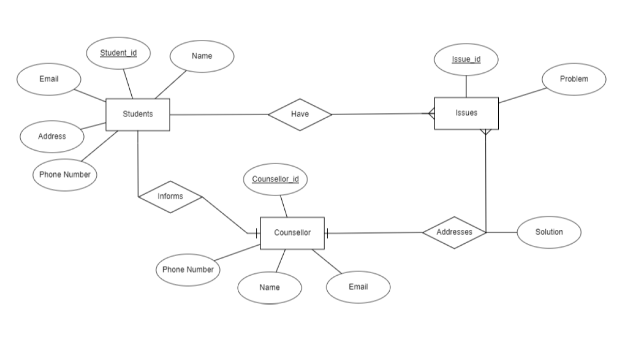
Database Design

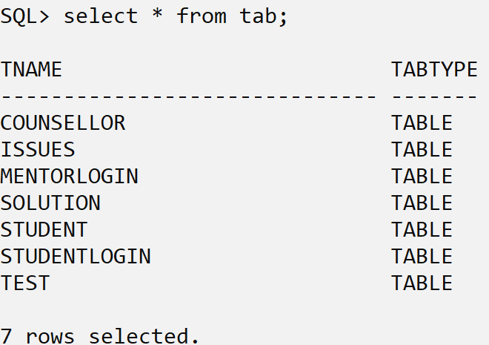

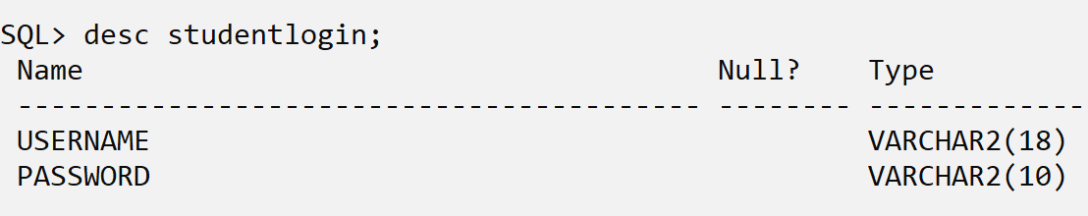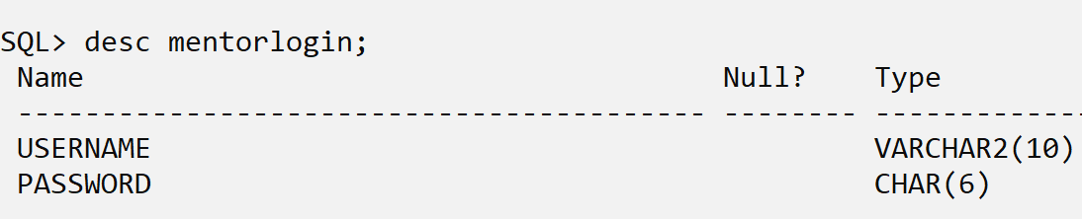

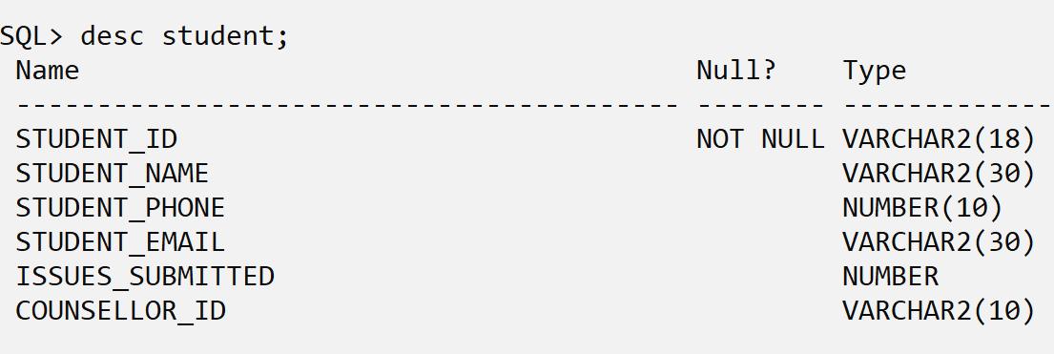

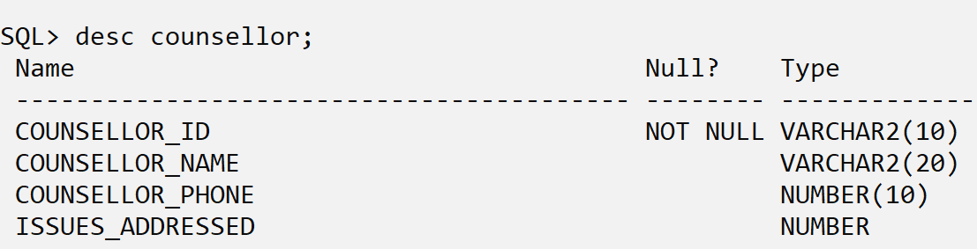

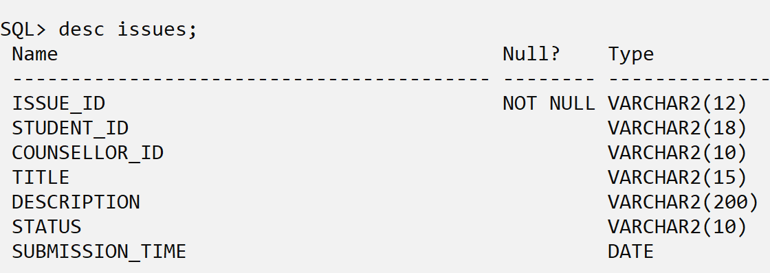

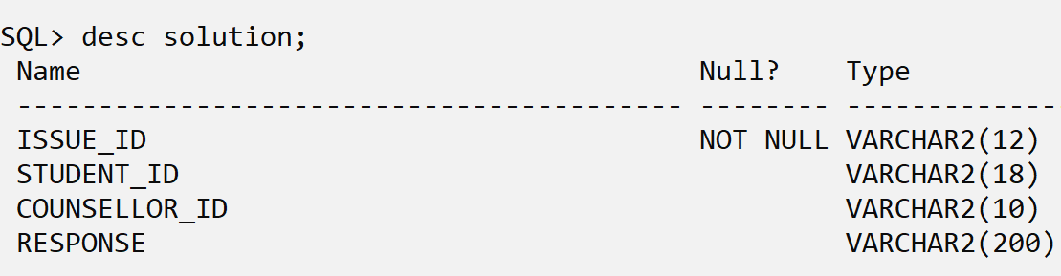

IMPLEMENTATION:

PROGRAM:

HOMEPAGE

package Main;

import UI.StudentUI.StudentLoginUI;
import UI.CounsellorUI.CounsellorLoginUI;

public class HomePageUI extends javax.swing.JFrame {

public HomePageUI() {
initComponents();
}

private void initComponents() {

jPanel1 = new javax.swing.JPanel();
jLabel4 = new javax.swing.JLabel();
jPanel2 = new javax.swing.JPanel();
jLabel1 = new javax.swing.JLabel();
jLabel2 = new javax.swing.JLabel();
studentButton = new javax.swing.JButton();
teacherButton = new javax.swing.JButton();
jLabel3 = new javax.swing.JLabel();

setDefaultCloseOperation(javax.swing.WindowConstants.EXIT_ON_CLOSE);
setTitle("Personal Counselling Management ");

jPanel1.setBackground(new java.awt.Color(153, 204, 255));

jLabel4.setIcon(new javax.swing.ImageIcon("D:\\VASAVI\\4th SEM\\Assignment\\DBMS\\DBMS Assignment 2\\loginim.jpg")); // NOI18N

javax.swing.GroupLayout jPanel1Layout = new javax.swing.GroupLayout(jPanel1);
jPanel1.setLayout(jPanel1Layout);
jPanel1Layout.setHorizontalGroup(
jPanel1Layout.createParallelGroup(javax.swing.GroupLayout.Alignment.LEADING)
.addGroup(javax.swing.GroupLayout.Alignment.TRAILING, jPanel1Layout.createSequentialGroup()
.addContainerGap()
.addComponent(jLabel4, javax.swing.GroupLayout.DEFAULT_SIZE, 803, Short.MAX_VALUE)
.addContainerGap())
);
jPanel1Layout.setVerticalGroup(
jPanel1Layout.createParallelGroup(javax.swing.GroupLayout.Alignment.LEADING)
.addGroup(jPanel1Layout.createSequentialGroup()
.addGap(20, 20, 20)
.addComponent(jLabel4, javax.swing.GroupLayout.PREFERRED_SIZE, 0, Short.MAX_VALUE)
.addGap(30, 30, 30))
);

jPanel2.setBackground(new java.awt.Color(255, 255, 255));

jLabel1.setFont(new java.awt.Font("Segoe UI Light", 1, 30)); // NOI18N
jLabel1.setText("Hey There !");

jLabel2.setFont(new java.awt.Font("Segoe UI Light", 1, 30)); // NOI18N
jLabel2.setText("Are you a :");

studentButton.setBackground(new java.awt.Color(102, 204, 255));
studentButton.setFont(new java.awt.Font("SimSun", 1, 26)); // NOI18N
studentButton.setText("Student");
studentButton.addActionListener(new java.awt.event.ActionListener() {
public void actionPerformed(java.awt.event.ActionEvent evt) {
studentButtonActionPerformed(evt);
}
});

teacherButton.setBackground(new java.awt.Color(102, 204, 255));
teacherButton.setFont(new java.awt.Font("SimSun", 1, 26)); // NOI18N
teacherButton.setText("Teacher");
teacherButton.addActionListener(new java.awt.event.ActionListener() {
public void actionPerformed(java.awt.event.ActionEvent evt) {
teacherButtonActionPerformed(evt);
}
});

jLabel3.setFont(new java.awt.Font("Segoe UI Light", 1, 30)); // NOI18N
jLabel3.setText("OR");

javax.swing.GroupLayout jPanel2Layout = new javax.swing.GroupLayout(jPanel2);
jPanel2.setLayout(jPanel2Layout);
jPanel2Layout.setHorizontalGroup(
jPanel2Layout.createParallelGroup(javax.swing.GroupLayout.Alignment.LEADING)
.

pack();
}// </editor-fold>

private void teacherButtonActionPerformed(java.awt.event.ActionEvent evt) {
// TODO add your handling code here:
new CounsellorLoginUI().show();
dispose();
}

private void studentButtonActionPerformed(java.awt.event.ActionEvent evt) {
// TODO add your handling code here:
new StudentLoginUI().show();
dispose();
}

public static void main(String args[]) {
try {
for (javax.swing.UIManager.LookAndFeelInfo info : javax.swing.UIManager.getInstalledLookAndFeels()) {
if ("Nimbus".equals(info.getName())) {
javax.swing.UIManager.setLookAndFeel(info.getClassName());
break;
}
}
} catch (ClassNotFoundException ex) {
java.util.logging.Logger.getLogger(HomePageUI.class.getName()).log(java.util.logging.Level.SEVERE, null, ex);
} catch (InstantiationException ex) {
java.util.logging.Logger.getLogger(HomePageUI.class.getName()).log(java.util.logging.Level.SEVERE, null, ex);
} catch (IllegalAccessException ex) {
java.util.logging.Logger.getLogger(HomePageUI.class.getName()).log(java.util.logging.Level.SEVERE, null, ex);
} catch (javax.swing.UnsupportedLookAndFeelException ex) {
java.util.logging.Logger.getLogger(HomePageUI.class.getName()).log(java.util.logging.Level.SEVERE, null, ex);
}
//</editor-fold>

/* Create and display the form */
java.awt.EventQueue.invokeLater(new Runnable() {
public void run() {
new HomePageUI().setVisible(true);
}
});
}

// Variables declaration - do not modify
private javax.swing.JLabel jLabel1;
private javax.swing.JLabel jLabel2;
private javax.swing.JLabel jLabel3;
private javax.swing.JLabel jLabel4;
private javax.swing.JPanel jPanel1;
private javax.swing.JPanel jPanel2;
private javax.swing.JButton studentButton;
private javax.swing.JButton teacherButton;
// End of variables declaration
}

LOGINPAGE

package UI.StudentUI;
import DBConnection.DBStudentConnect;
import javax.swing.JOptionPane;
import Main.HomePageUI;
public class StudentLoginUI extends javax.swing.JFrame {

public StudentLoginUI() {
initComponents();
}

private void initComponents() {

jPanel1 = new javax.swing.JPanel();
jLabel2 = new javax.swing.JLabel();
jPanel2 = new javax.swing.JPanel();
jLabel1 = new javax.swing.JLabel();
usernameTextField = new javax.swing.JTextField();
passwordTextField = new javax.swing.JPasswordField();
loginButton = new javax.swing.JButton();
goBackButton = new javax.swing.JButton();

setDefaultCloseOperation(javax.swing.WindowConstants.DISPOSE_ON_CLOSE);
setTitle("LoginPage");

jPanel1.setBackground(new java.awt.Color(102, 204, 255));

jLabel2.setIcon(new javax.swing.ImageIcon("D:\\VASAVI\\4th SEM\\Assignment\\DBMS\\DBMS Assignment 2\\DBMS\\src\\UI\\StudentUI\\images\\Studentlogin.png")); // NOI18N

javax.swing.GroupLayout jPanel1Layout = new javax.swing.GroupLayout(jPanel1);
jPanel1.setLayout(jPanel1Layout);
jPanel1Layout.setHorizontalGroup(
jPanel1Layout.createParallelGroup(javax.swing.GroupLayout.Alignment.LEADING)
.addGroup(jPanel1Layout.createSequentialGroup()
.addGap(14, 14, 14)
.addComponent(jLabel2, javax.swing.GroupLayout.PREFERRED_SIZE, 332, javax.swing.GroupLayout.PREFERRED_SIZE)
.addContainerGap(23, Short.MAX_VALUE))
);
jPanel1Layout.setVerticalGroup(
jPanel1Layout.createParallelGroup(javax.swing.GroupLayout.Alignment.LEADING)
.addGroup(jPanel1Layout.createSequentialGroup()
.addGap(165, 165, 165)
.addComponent(jLabel2, javax.swing.GroupLayout.PREFERRED_SIZE, 227, javax.swing.GroupLayout.PREFERRED_SIZE)
.addContainerGap(javax.swing.GroupLayout.DEFAULT_SIZE, Short.MAX_VALUE))
);

jPanel2.setBackground(new java.awt.Color(255, 255, 255));
jPanel2.setPreferredSize(new java.awt.Dimension(400, 540));
});

javax.swing.GroupLayout jPanel2Layout = new javax.swing.GroupLayout(jPanel2);
jPanel2.setLayout(jPanel2Layout);
jPanel2Layout.setHorizontalGroup(
jPanel2Layout.createParallelGroup(javax.swing.GroupLayout.Alignment.LEADING)
.addGroup(jPanel2Layout.createSequentialGroup()
.addGroup(jPanel2Layout.createParallelGroup(javax.swing.GroupLayout.Alignment.LEADING)
.addGroup(jPanel2Layout.createSequentialGroup()
.addGap(53, 53, 53)
.addComponent(jLabel1, javax.swing.GroupLayout.PREFERRED_SIZE, 325, javax.swing.GroupLayout.PREFERRED_SIZE))
.addGroup(jPanel2Layout.createSequentialGroup()
.addGap(113, 113, 113)
.addGroup(jPanel2Layout.createParallelGroup(javax.swing.GroupLayout.Alignment.LEADING)
.addGroup(jPanel2Layout.createParallelGroup(javax.swing.GroupLayout.Alignment.TRAILING)

pack();
}// </editor-fold>

private void usernameTextFieldActionPerformed(java.awt.event.ActionEvent evt) {
// TODO add your handling code here:
}

private void passwordTextFieldActionPerformed(java.awt.event.ActionEvent evt) {
// TODO add your handling code here:
}

private void goBackButtonActionPerformed(java.awt.event.ActionEvent evt) {
// TODO add your handling code here:
new HomePageUI().show();
dispose();
}

private void loginButtonActionPerformed(java.awt.event.ActionEvent evt) {
// TODO add your handling code here:
try
{
DBStudentConnect db =new DBStudentConnect();
db.connect();
String username = usernameTextField.getText();
if(db.verifyLogin(username,passwordTextField.getText()))
{
dispose();
new StudentUI(username).show();
}

else
{
usernameTextField.setText("");
passwordTextField.setText("");
JOptionPane.showMessageDialog(this,"Invalid UserID / Password","Error",JOptionPane.ERROR_MESSAGE);
}
db.st.close();
db.conn.close();
}
catch(Exception e)
{
System.out.println(e);
}
}

try {
for (javax.swing.UIManager.LookAndFeelInfo info : javax.swing.UIManager.getInstalledLookAndFeels()) {
if ("Nimbus".equals(info.getName())) {
javax.swing.UIManager.setLookAndFeel(info.getClassName());
break;
}
}
} catch (ClassNotFoundException ex) {
java.util.logging.Logger.getLogger(StudentLoginUI.class.getName()).log(java.util.logging.Level.SEVERE, null, ex);
} catch (InstantiationException ex) {
java.util.logging.Logger.getLogger(StudentLoginUI.class.getName()).log(java.util.logging.Level.SEVERE, null, ex);
} catch (IllegalAccessException ex) {
java.util.logging.Logger.getLogger(StudentLoginUI.class.getName()).log(java.util.logging.Level.SEVERE, null, ex);
} catch (javax.swing.UnsupportedLookAndFeelException ex) {
java.util.logging.Logger.getLogger(StudentLoginUI.class.getName()).log(java.util.logging.Level.SEVERE, null, ex);
}
//</editor-fold>

/* Create and display the form */
java.awt.EventQueue.invokeLater(new Runnable() {
public void run() {
new StudentLoginUI().setVisible(true);
}
});
}

// Variables declaration - do not modify
private javax.swing.JButton goBackButton;
private javax.swing.JLabel jLabel1;
private javax.swing.JLabel jLabel2;
private javax.swing.JPanel jPanel1;
private javax.swing.JPanel jPanel2;
private javax.swing.JButton loginButton;
private javax.swing.JPasswordField passwordTextField;
private javax.swing.JTextField usernameTextField;
// End of variables declaration
}

STUDENT UI
package UI.StudentUI;
import DBConnection.DBStudentConnect;

import javax.swing.JOptionPane;
import javax.swing.table.DefaultTableModel;

public class StudentUI extends javax.swing.JFrame {

/**
* Creates new form StudentUI
*/
public DBStudentConnect db = new DBStudentConnect();
public String username;
public int issuesCount;

public StudentUI(String username) {
this.username = username;
db.connect();

initComponents();

putStudentData();
putTableData();
}

/**
* This method is called from within the constructor to initialize the form.
* WARNING: Do NOT modify this code. The content of this method is always
* regenerated by the Form Editor.
*/
@SuppressWarnings("unchecked")
// <editor-fold defaultstate="collapsed" desc="Generated Code">
private void initComponents() {

welcomeLabel = new javax.swing.JLabel();
jLabel2 = new javax.swing.JLabel();
jScrollPane1 = new javax.swing.JScrollPane();
issuesTable = new javax.swing.JTable();
viewButton = new javax.swing.JButton();
modifyButton = new javax.swing.JButton();
deleteButton = new javax.swing.JButton();
issueButton = new javax.swing.JButton();
counsellorLabel = new javax.swing.JLabel();
phnoLabel = new javax.swing.JLabel();
logOutButton = new javax.swing.JButton();

setDefaultCloseOperation(javax.swing.WindowConstants.EXIT_ON_CLOSE);
setTitle("Student Page");
setBackground(new java.awt.Color(153, 153, 255));
setFont(new java.awt.Font("Agency FB", 0, 24)); // NOI18N
setForeground(new java.awt.Color(0, 153, 153));
setResizable(false);

welcomeLabel.setFont(new java.awt.Font("Segoe UI", 0, 24)); // NOI18N
welcomeLabel.setText("Welcome");

jLabel2.setFont(new java.awt.Font("Segoe UI", 0, 24)); // NOI18N
jLabel2.setText("Your Issues:");

issuesTable.setBorder(new javax.swing.border.LineBorder(new java.awt.Color(0, 0, 0), 1, true));
issuesTable.setFont(new java.awt.Font("SimSun", 0, 20)); // NOI18N
issuesTable.setModel(new javax.swing.table.DefaultTableModel(
new Object [][] {

},
new String [] {
"S.No", "Issue ID", "Title", "Status"
}
) {
Class[] types = new Class [] {
});

int r = issuesTable.getSelectedRow();

if(r<0)
JOptionPane.showMessageDialog(this,"Please select a row", "Notice", JOptionPane.INFORMATION_MESSAGE);
else
{
String id =(String) issuesTable.getValueAt(r, 1);
new ViewUI(id).show();
}
// TODO add your handling code here:
}

private void issueButtonActionPerformed(java.awt.event.ActionEvent evt) {
// TODO add your handling code here:

new NewIssueUI(username,this).show();
// db.addIssue(username, title, problem);
// putTableData();
}

private void modifyButtonActionPerformed(java.awt.event.ActionEvent evt) {
// TODO add your handling code here:
int r = issuesTable.getSelectedRow();

if(r<0)
JOptionPane.showMessageDialog(
}

else
{
String msg = "Are you sure you want to delete this issue?";
int option = JOptionPane.showConfirmDialog(this,msg,"Delete",JOptionPane.YES_NO_OPTION);
if(option==0)
{
String id =(String) issuesTable.getValueAt(r, 1);
db.deleteStudentIssue(id,username);
putTableData();
}
}
issuesTable.clearSelection();
}
}

private void logOutButtonActionPerformed(java.awt.event.ActionEvent evt) {
// TODO add your handling code here:
String msg = "This will take you to HomePage\nAre you sure?";
int option = JOptionPane.showConfirmDialog(this,msg,"LogOut",JOptionPane.YES_NO_OPTION);
if(option==0)
{
new Main.HomePageUI().show();
dispose();
}
}

final void putStudentData()
{
try
{
db.fetchStudentData(username);
welcomeLabel.setText("Welcome "+db.rs.getString(1)+" !");
counsellorLabel.setText("Counsellor: "+db.rs.getString(2));
phnoLabel.setText("Phone No: "+db.rs.getString(3));

}

catch(Exception e)
{
System.out.print("Error putData: "+e);
}
}

}

catch(Exception e)
{
System.out.println("Put table error: "+e);
}
}

/**
* @param args the command line arguments
*/
public static void main(String args[]) {
/* Set the Nimbus look and feel */
//<editor-fold defaultstate="collapsed" desc=" Look and feel setting code (optional) ">
/* If Nimbus (introduced in Java SE 6) is not available, stay with the default look and feel.
* For details see http://download.oracle.com/javase/tutorial/uiswing/lookandfeel/plaf.html
*/
try {
for (javax.swing.UIManager.LookAndFeelInfo info : javax.swing.UIManager.getInstalledLookAndFeels()) {
if ("Nimbus".equals(info.getName())) {
javax.swing.UIManager.setLookAndFeel(info.getClassName());
break;
}
}
} catch (ClassNotFoundException ex) {
java.util.logging.Logger.getLogger(StudentUI.class.getName()).log(java.util.logging.Level.SEVERE, null, ex);
} catch (InstantiationException ex) {
java.util.logging.Logger.getLogger(StudentUI.class.getName()).log(java.util.logging.Level.SEVERE, null, ex);
} catch (IllegalAccessException ex) {
java.util.logging.Logger.getLogger(StudentUI.class.getName()).log(java.util.logging.Level.SEVERE, null, ex);
} catch (javax.swing.UnsupportedLookAndFeelException ex) {
java.util.logging.Logger.getLogger(StudentUI.class.getName()).log(java.util.logging.Level.SEVERE, null, ex);
}
//</editor-fold>

/* Create and display the form */
java.awt.EventQueue.invokeLater(new Runnable() {
public void run() {
new StudentUI("1602-20-737-043").setVisible(true);
}
});
}

// Variables declaration - do not modify
private javax.swing.JLabel counsellorLabel;
private javax.swing.JButton deleteButton;
private javax.swing.JButton issueButton;
private javax.swing.JTable issuesTable;
private javax.swing.JLabel jLabel2;
private javax.swing.JScrollPane jScrollPane1;
private javax.swing.JButton logOutButton;
private javax.swing.JButton modifyButton;
private javax.swing.JLabel phnoLabel;
private javax.swing.JButton viewButton;
private javax.swing.JLabel welcomeLabel;
// End of variables declaration
}

COUNSELLOR UI
package UI.CounsellorUI;

import javax.swing.JOptionPane;
import DBConnection.DBCounsellorConnect;
import UI.StudentUI.ModifyUI;
import java.text.DateFormat;
import java.text.SimpleDateFormat;
import java.util.Date;
import javax.swing.JPanel;
import javax.swing.table.DefaultTableModel;
/**
*
* @author SURYA DEVARAKONDA
*/
public class CounsellorUI extends javax.swing.JFrame {

/**
* Creates new form CounsellorUI
*/
DBCounsellorConnect db = new DBCounsellorConnect();
String username;

public CounsellorUI(String u) {
username = u;
db.connect();
initComponents();
changeTableWidth();
putCounsellorData();
putTableData();
putStatistics();
putStudentsList();
}

/**
* This method is called from within the constructor to initialize the form.
* WARNING: Do NOT modify this code. The content of this method is always
* regenerated by the Form Editor.
*/
}

.YES_NO_OPTION);

if(option==0)
{
String id =(String) responsesTable.getValueAt(r, 1);
db.deleteResponse(id,username);
}

JOptionPane.showMessageDialog(this,"Your response has been removed.", "Notice", JOptionPane.INFORMATION_MESSAGE);

putTableData();
putCounsellorData();
}
}

private void modifyButtonActionPerformed(java.awt.event.ActionEvent evt) {
// TODO add your handling code here:
catch(Exception e)
{
System.out.println(e);
}
}

void putStatistics()
{
try
{
db.getStatistics(username);
DefaultTableModel model = (DefaultTableModel) statisticsTable.getModel();
model.setRowCount(0);
String name,issues;

while(db.rs.next())
{
name = db.rs.getString(1);
issues = db.rs.getString(2);

String rowData[]={name,issues};
model.addRow(rowData);
}
}

if(responsesTable.getRowCount()==0)
{
JOptionPane.showMessageDialog(this,"No records found.","Notice",JOptionPane.INFORMATION_MESSAGE);
studentList.setSelectedIndex(0);
dateChooser.setCalendar(null);
}
}

catch(Exception e)
{
System.out.println(e);
}
}

public static void main(String args[]) {
/* Set the Nimbus look and feel */
//<editor-fold defaultstate="collapsed" desc=" Look and feel setting code (optional) ">
/* If Nimbus (introduced in Java SE 6) is not available, stay with the default look and feel.
* For details see http://download.oracle.com/javase/tutorial/uiswing/lookandfeel/plaf.html
*/
try {
for (javax.swing.UIManager.LookAndFeelInfo info : javax.swing.UIManager.getInstalledLookAndFeels()) {
if ("Nimbus".equals(info.getName())) {
javax.swing.UIManager.setLookAndFeel(info.getClassName());
break;
}
}
} catch (ClassNotFoundException ex) {
java.util.logging.Logger.getLogger(CounsellorUI.class.getName()).log(java.util.logging.Level.SEVERE, null, ex);
} catch (InstantiationException ex) {
java.util.logging.Logger.getLogger(CounsellorUI.class.getName()).log(java.util.logging.Level.SEVERE, null, ex);
} catch (IllegalAccessException ex) {
java.util.logging.Logger.getLogger(CounsellorUI.class.getName()).log(java.util.logging.Level.SEVERE, null, ex);
} catch (javax.swing.UnsupportedLookAndFeelException ex) {
java.util.logging.Logger.getLogger(CounsellorUI.class.getName()).log(java.util.logging.Level.SEVERE, null, ex);
}
//</editor-fold>

/* Create and display the form */
java.awt.EventQueue.invokeLater(new Runnable() {
public void run() {
new CounsellorUI("2025").setVisible(true);

}
});

}

// Variables declaration - do not modify
private javax.swing.JButton clearFilterButton;
private com.toedter.calendar.JDateChooser dateChooser;
private javax.swing.JButton dateFetchButton;
private javax.swing.JButton deleteButton;
private javax.swing.JLabel issuesLabel;
private javax.swing.JLabel jLabel1;
private javax.swing.JLabel jLabel2;
private javax.swing.JLabel jLabel3;
private javax.swing.JLabel jLabel314;
private javax.swing.JLabel jLabel4;
private javax.swing.JLabel jLabel5;
private javax.swing.JPanel jPanel1;
private javax.swing.JPanel jPanel2;
private javax.swing.JScrollPane jScrollPane1;
private javax.swing.JScrollPane jScrollPane2;
private javax.swing.JScrollPane jScrollPane3;
private javax.swing.JTabbedPane jTabbedPane2;
private javax.swing.JButton logoutButton;
private javax.swing.JButton modifyButton;
private javax.swing.JTable pendingIssuesTable;
private javax.swing.JButton respondButton;
private javax.swing.JTable responsesTable;
private javax.swing.JTable statisticsTable;
private javax.swing.JComboBox<String> studentList;
private javax.swing.JButton viewButton;
private javax.swing.JButton viewButton1;

DATABASE CONNECTION

package DBConnection;

import java.sql.*;
/**
*
* @author SURYA DEVARAKONDA
*/
public class DBCounsellorConnect {
public ResultSet rs;
public Statement st;
public Connection conn;

public void connect()
{
try
{
Class.forName("oracle.jdbc.driver.OracleDriver");
conn = DriverManager.getConnection("jdbc:oracle:thin:@localhost:1521:xe","surya","surya123");
st = conn.createStatement();
}

catch(Exception e)
{
System.out.println("Exception: "+e);
}
}

public boolean verifyLogin(String id,String pssw) throws SQLException
{
String q = "where username= '"+id+"' and password='"+pssw+"'";
rs = st.executeQuery("select * from mentorlogin "+q);

if(rs.next())
return true;

else
return false;
}

public void fetchCounsellorData(String id)
{
try
{
rs = st.executeQuery("select counsellor_name,issues_addressed from counsellor where counsellor_id='"+id+"'");
rs.next();
}
catch (Exception e)
{
System.out.println(e);
}
}

public void fetchTableData(String id)
{
try
{
String q = "select i.issue_id,s.STUDENT_NAME,i.title,i.status,i.submission_time from student s inner join issues i on s.student_id = i.student_id and s.counsellor_id='"+id+"'";
rs = st.executeQuery(q);
}
catch (Exception e)
{
System.out.println(e);
}

}

public void viewPendingStudentIssue(String id)
{
try
{
String q = "select i.issue_id,s.student_name,i.title,i.description from issues i inner join student s on i.student_id = s.student_id and i.issue_id='"+id+"'";
rs = st.executeQuery(q);
rs.next();
}
catch (Exception e)
{
System.out.println(e);
}
}

public void viewRespondedStudentIssue(String id)
{
try
{
rs = st.executeQuery("select response from solution where issue_id='"+id+"'");
rs.next();
}

catch (Exception e)
{
System.out.println(e);
}
}

public void respondIssue(String id,String response,String c_id)
{
try
{
String q = "update issues set status='Responded' where issue_id='"+id+"'";
st.executeQuery(q);
System.out.println("1");
q = "update solution set response='"+response+"' where issue_id='"+id+"'";
st.executeQuery(q);
System.out.println("2");
q="select issues_addressed from counsellor where counsellor_id='"+c_id+"'";
rs = st.executeQuery(q);
System.out.println("3");
rs.next();
int count = rs.getInt(1);
count++;

q="update counsellor set issues_addressed='"+count+"' where counsellor_id='"+c_id+"'";
st.executeQuery(q);
System.out.println("4");
}

catch(Exception e)
{
System.out.println("respond isue: "+e);
}
}

public void getStatistics(String c_id)
{
try
{
String q = "select student_name,issues_submitted from student where counsellor_id='"+c_id+"' order by 2 desc";
rs = st.executeQuery(q);
}

catch(Exception e)
{
System.out.println("respond isue: "+e);
}

}

public void updateResponse(String id,String response)
{
try
{
String q = "update solution set response='"+response+"' where issue_id='"+id+"'";
st.executeQuery(q);

}

catch(Exception e)
{
System.out.println(e);
}
GIT HUB Links and Folder Structure

https://github.com/thedevarakonda/Personal-Counselling-Management-System.git

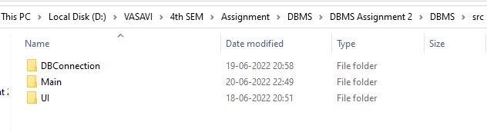

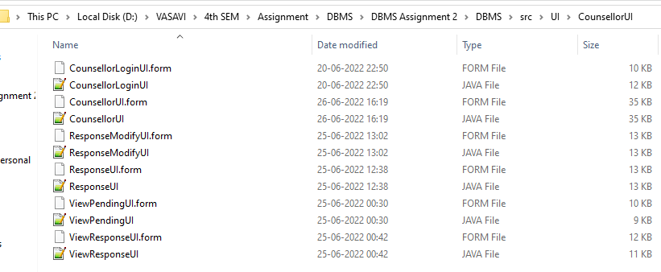

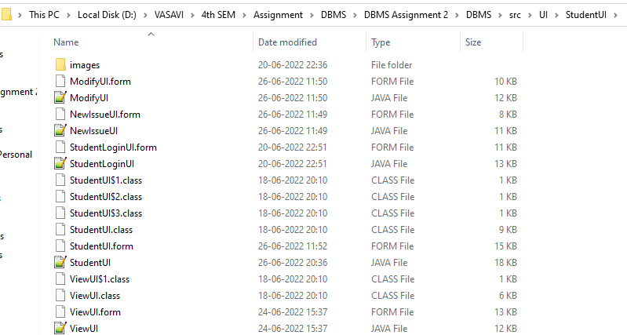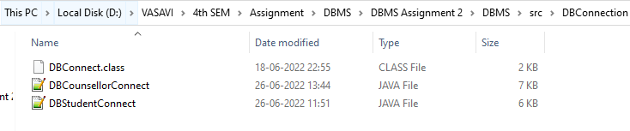

Testing:

Java GUI Testing:
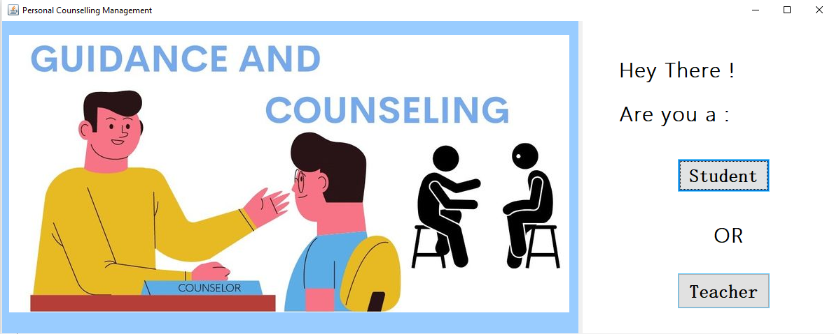

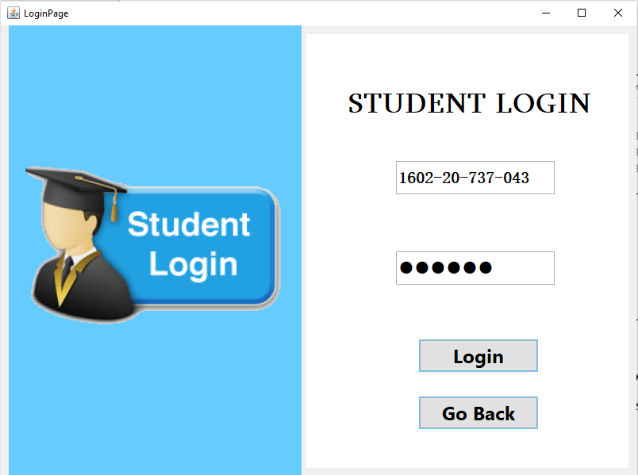

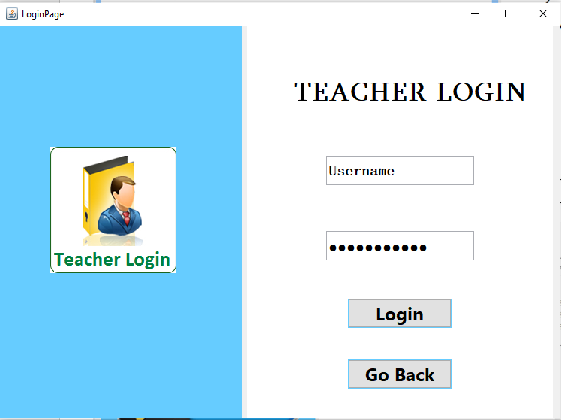

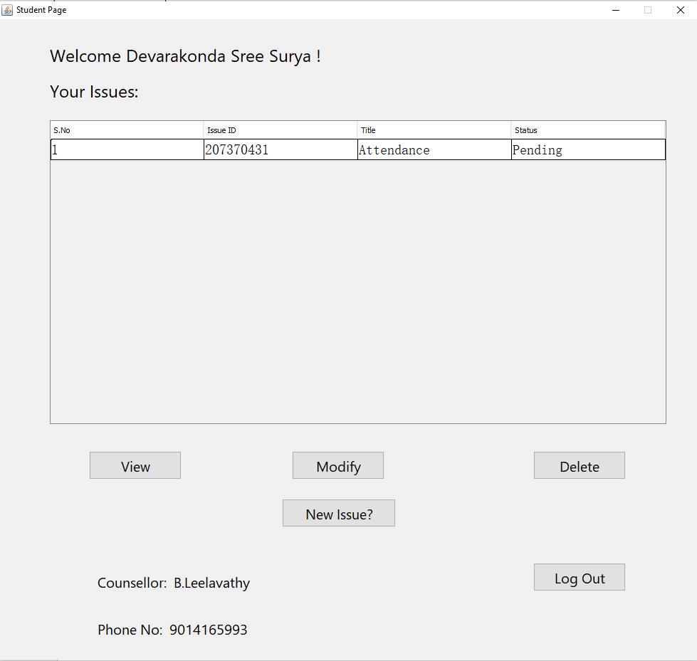

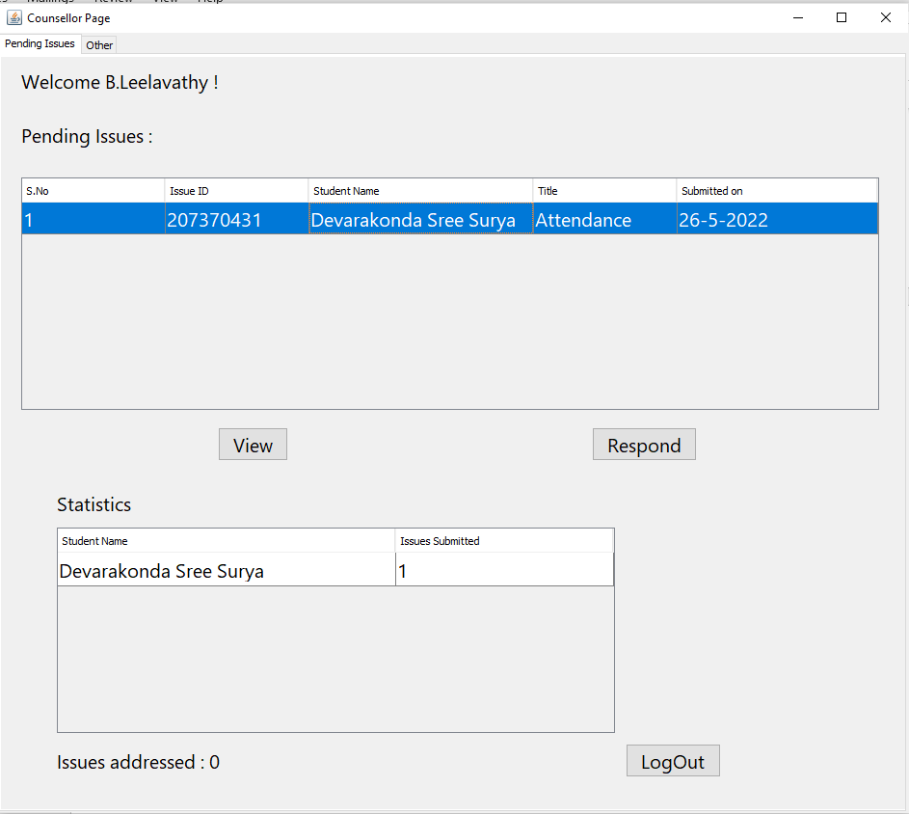

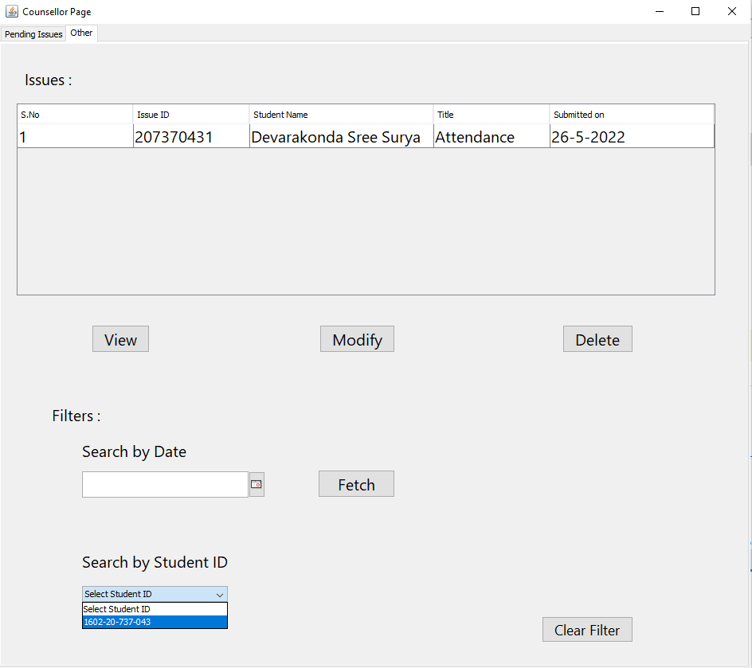

The data entered in the above form is updated in the “Issues” table of the Oracle database 11g as:
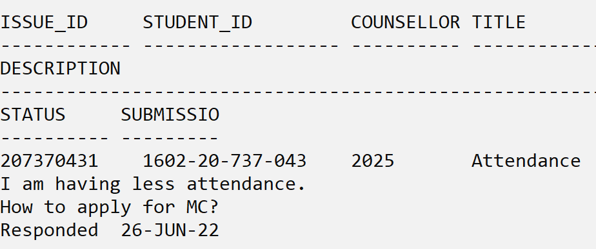

Results:
I successfully completed this MINI PROJECT “Personal Counselling Management System”.

Discussion and Future work
While doing this project I got new ideas I understood how to work on projects. This project has been a huge learning curve for me as I have learnt many new technologies. I also learnt how to write queries efficiently and I have a thorough understanding of DBMS. A huge credit goes to my mentor Ms.B.Leelavathy whose guidance and motivation has lead me to keep improving the project.
Now to further extend this project I want to create Android app so that this will be very handy for both students and mentors.

References:
- https://www.academia.edu/36893248/Ramakrishnan_-
_Database_Management_Systems_3rd_Edition
- https://docs.oracle.com/javase/7/docs/index.html
- https://www.javatpoint.com/dbms-tutorial
- http://www.sqlines.com/articles/java/sql_server_jdbc_connection

